Stefan Grulović (20150280)

Hirstos Hristodoulou

Computer Science 325: Distributed Applications

Spring 2018

**Word Report**

# Presentation

The application is intended to be an online planner through which a user can organize various thing. The program has 4 options: calendar, contacts, lists and notes. Initially the application had only the calendar and notes working, now contacts and lists have been implemented alongside with database connection.

The index page presents the user a *login* form through which they can login in case they already made an account or register.

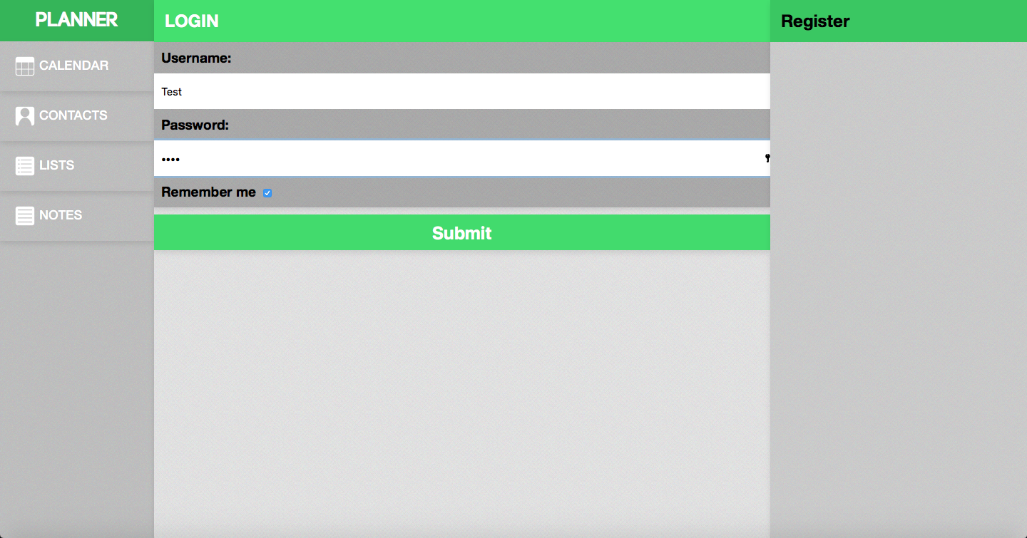

Example of the login/index page

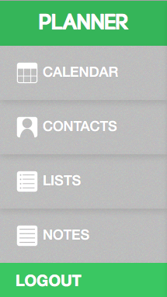

*Example of the navigation with new account functionality(logout)*

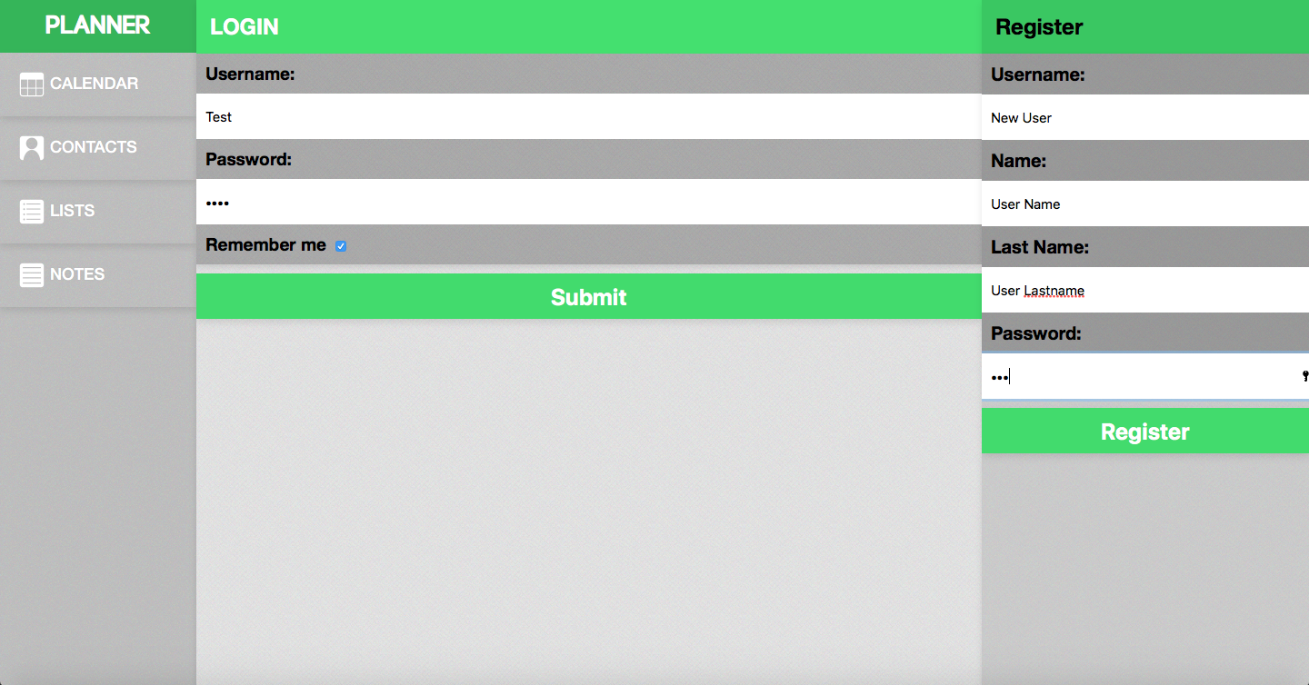

Example of the register form

# Contacts

The contacts are displayed in a list which when clicked on it displays the contact information. By clicking new contact button the user can insert into database a contact through a form. The contact list element has two clickable links, edit and delete, for editing through a form and deleting.

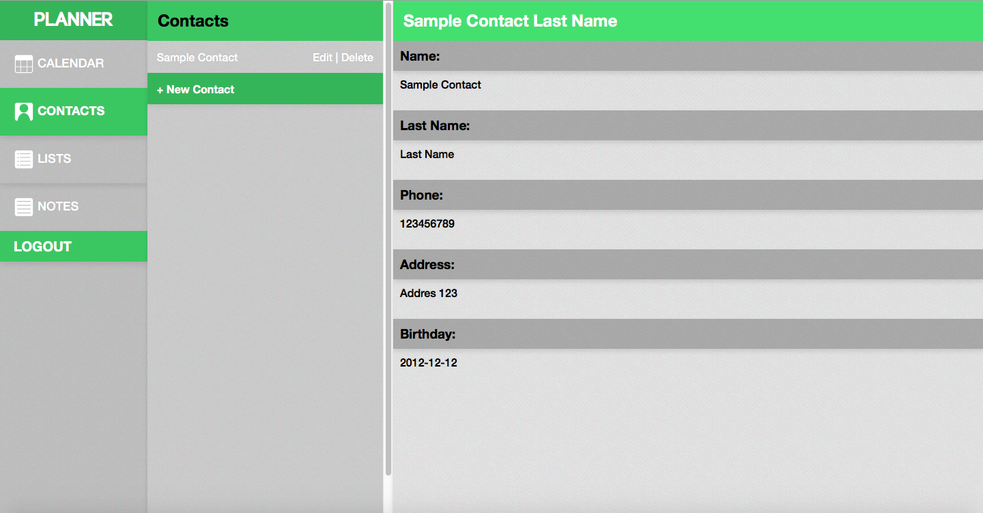

*Example of displaying sample contacts information*

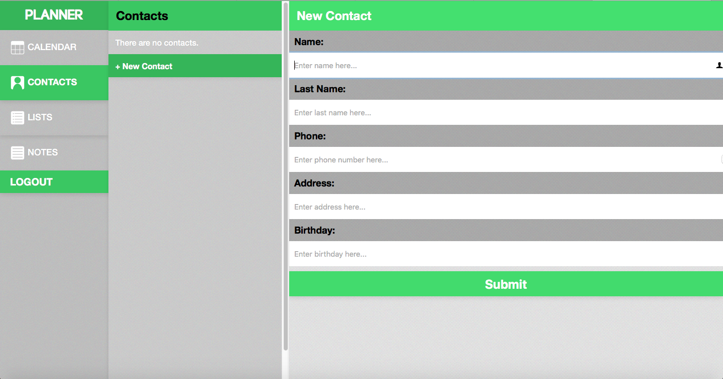

Example of contacts new contact form

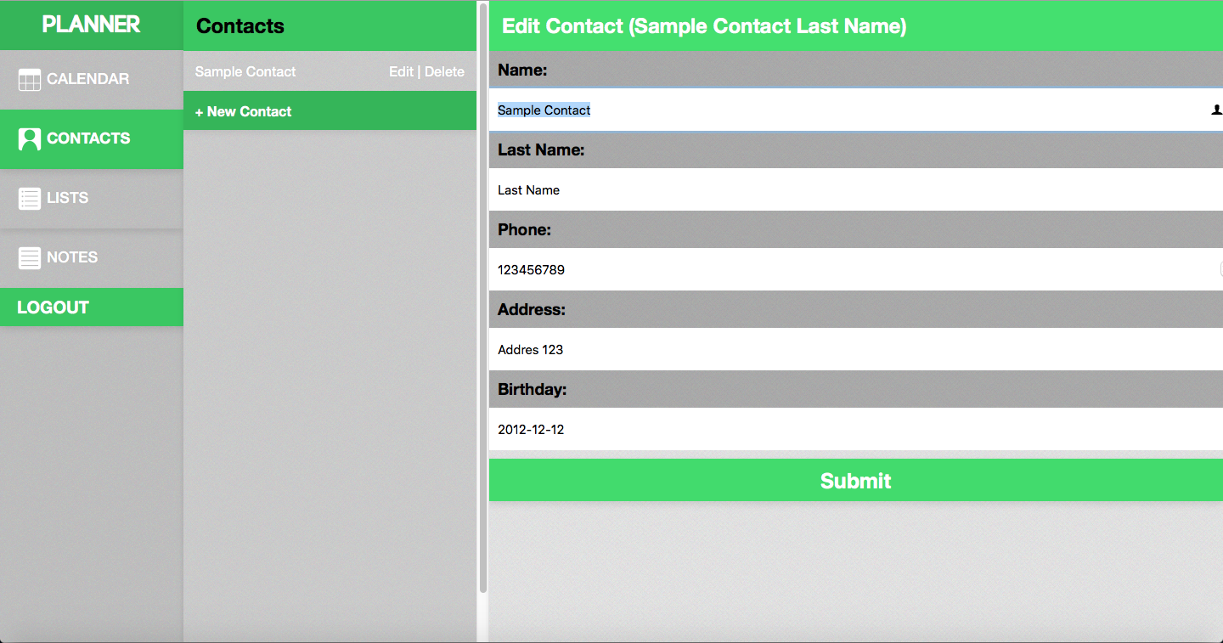

*Example of contact list element and edit form*

# Lists

The lists are displayed in a list element which when clicked on it displays the list points information. By clicking new point button the user can insert a new list through a form.

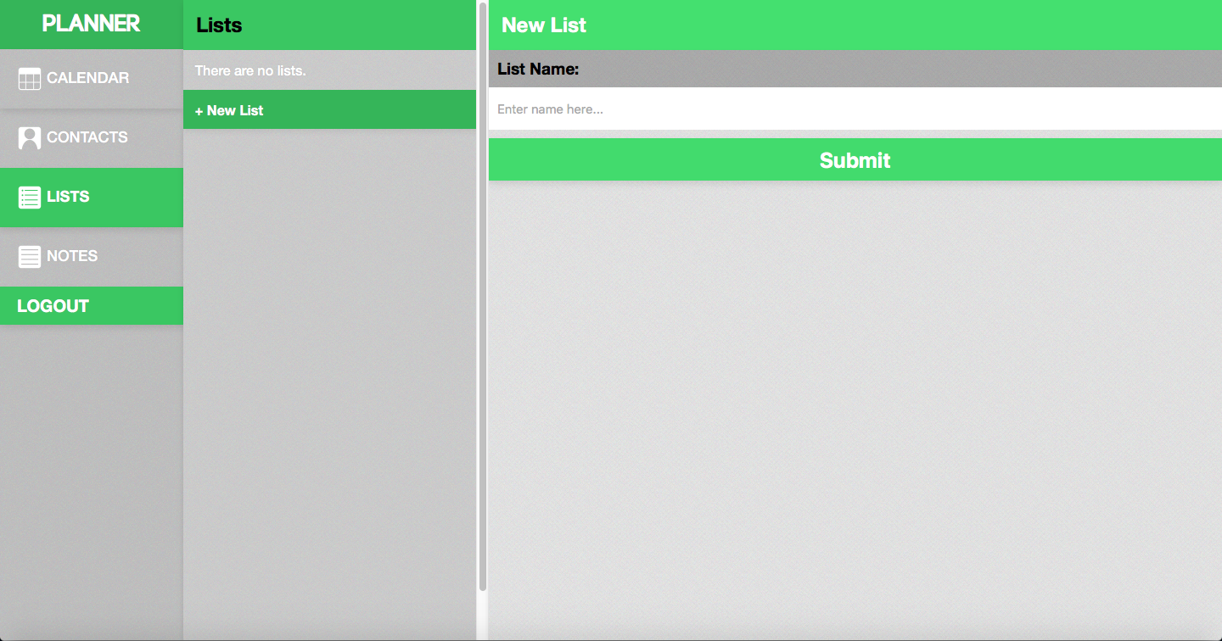

Example of list page and new list form

The list elements and point elements have two clickable links for editing through a form and deleting.

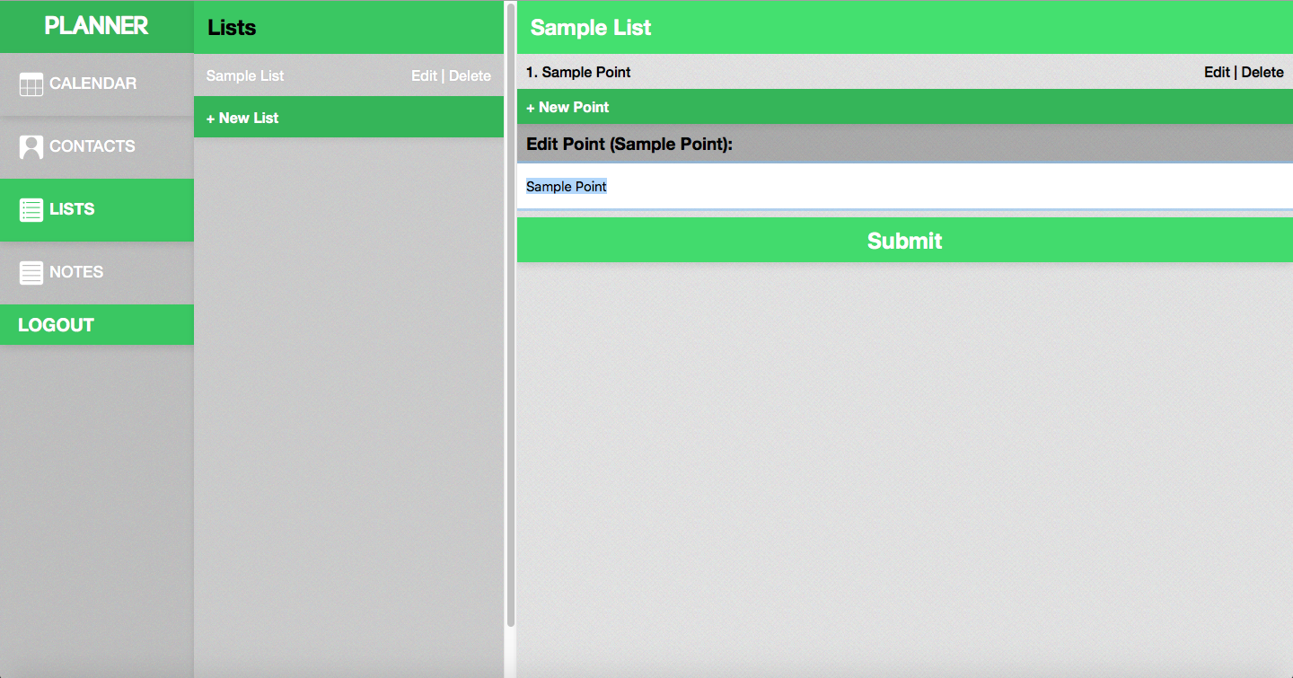

*Example of contact list element and edit form*

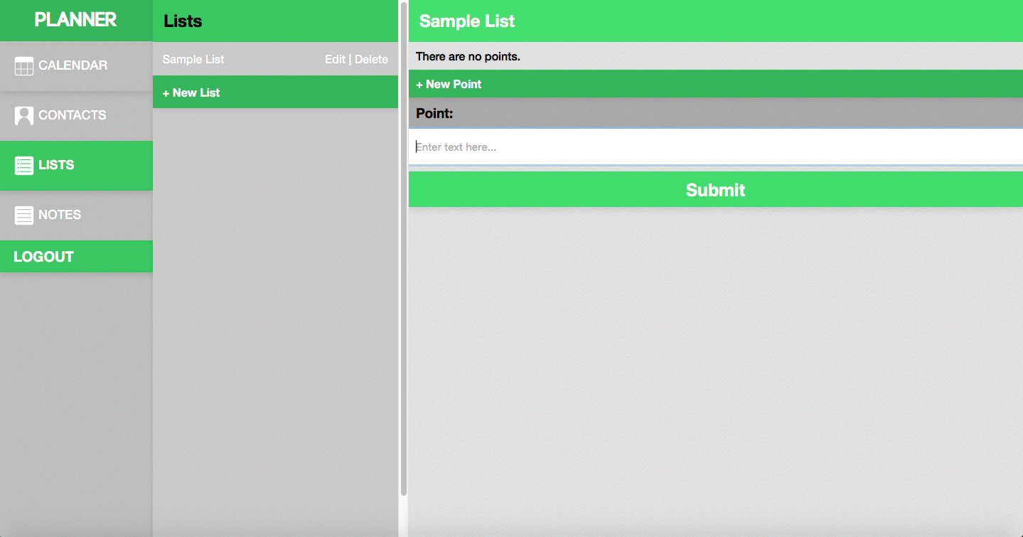

*Example of sample list and its points and insert form*

# File Description

The application consists 4 folders the *main* which holds the *fonts, images* and *styles.*

* The *main* folder holds the files which are separated in two parts the HTML page which calls the PHP functions (e.g. *index.php* and index_functions.php).
  + Also *DATABASE.sql* is located here which has the random generated data
* *Fonts* folder holds the specific fonts used in the webpage.
* *Images* which holds the navigation symbol images and the texture image used for page styling.
* *Styles* which has the CSS file used throughout the page.

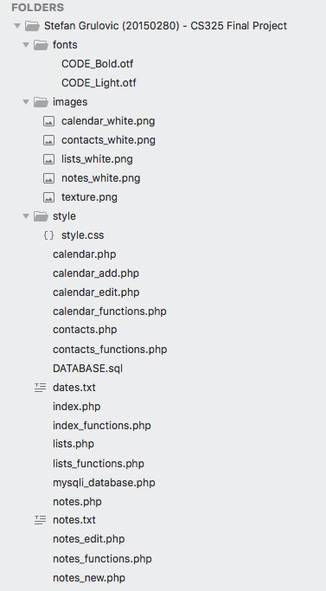

*Example of folder/file structure of the application.*

# Forms

There are two types of forms in all the options:

* *Insert* for inserting a new object/element
* *Edit* for editing an existing object

They consist of same amount of inputs the only difference is that the *insert* may have some optional and some required inputs while the *edit* inputs are all optional as the information is being edited and not inserted. The form uses $_POST for grabbing the information from the inputs after its submission.

The example of the forms is displayed in the presentation section.

# Application processing

The application uses the URL for communicating among which function to grab and information to send. URL usually holds *action* which specifies what the user has clicked which then calls to corresponding function and *element* (e.g. Contact or List element)

Each *page* has a corresponding *functions* file which holds the functions.

The functions consist of:

* + Class for objects with *get* and *set* functions
  + Functions for talking to database
    - *Select*
    - *Delete*
    - *Update*
  + Functions for *displaying* database data in specific form

# Table Description

There are 4 tables in the database:

* USERS
  + **USER_ID** – primary key
  + USER_LOGIN
  + USER_NAME
  + USER_PASSWORD
  + USER_ROLE
* CONTACTS
  + **CONTACT_ID** – primary key
  + CONTACT_NAME
  + CONTACT_LNAME
  + CONTACT_PHONE
  + CONTACT_ADDRESS
  + CONTACT_BIRTHDAY
  + *USER_CONTACTS* – foreign key to the users table
* LISTS
  + **LIST_ID** – primary key
  + LIST_NAME
  + *USER_LISTS* – foreign key to the users table
* LIST_POINTS
  + **POINT_ID** – primary key
  + POINT_CONTENT
  + *LIST_ID* – foreign key to the lists table

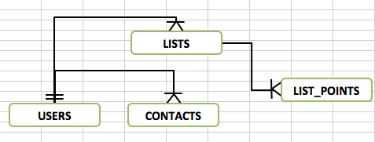

*Example of the tables ERD*

# Suggestions for further development

The application can be further expanded by adding new functionality and items and elements to store. Further expanding the applications main purpose and that is to plan and organise. Another nice functionality would be the ability to export data, which would allow a person to have his online data quickly in a format which can be converted to a physical format.

Regarding the logic, as the application has been upgraded to the database increasing its reachability and expandability. Cutting out the need to change logic and increasing the focus on expanding functionability of the application. However, with the increase of size of application it would be better to further improve the object-oriented programming within the application. As that would increase the speed and efficiency of further expanding and introducing new options.